**Facebook Login Requirement**

V1.1.0.0

Release History

|  |  |  |
| --- | --- | --- |
| Version | Date | Description |
| V1.0.0.0 | 2014-11-19 | First release |
| V1.1.0.0 | 2014-11-20 | Add a new requirement to get Facebook user ID for data binding purpose. |

**Table of Content**

1. Requirements 4

1-1 Requirement 1 4

1-2 Requirement 2 4

2. Facebook Login Code Snippet 6

2-1 Example for Android Java Programming Language 6

2-2 Example for iOS Objective-C Programming Language 8

2-3 Example for Unity C# Programming Language 9

# Requirements

## 1-1 Requirement 1

Facebook Login Dialog MUST use Facebook Embedded WebView Login Dialog

No matter Facebook App is installed or not in the device，user will only see Facebook Embedded WebView Login Dialog when user tries to login in with Facebook account.

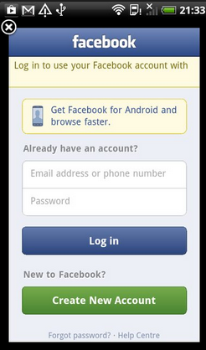

Facebook Embedded WebView Login Dialog

## 1-2 Requirement 2

Facebook Login Permission MUST include email permission

The reason why we need game developer to add Facebook email permission is that we collect user’s Facebook email for customer service purpose.

When a Facebook user is the first time login the app, the app will show the information about this app will collect use’s email address.

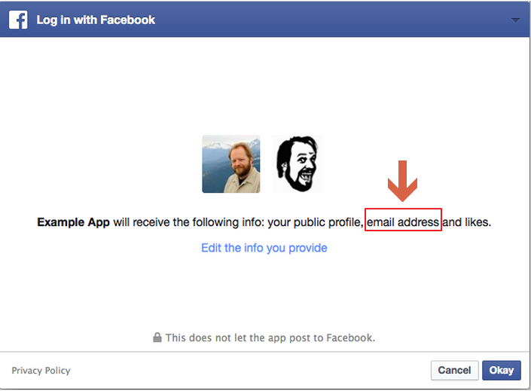

For information about Permissions with Facebook Login, please refer to

<https://developers.facebook.com/docs/facebook-login/permissions/v2.2#permission-email>

## 1-3 Requirement 3

The Facebook user ID MUST be retrieved for further data binding purpose.

This can be achieved by calling Facebook Graph API version 2.0(or above)

# Facebook Login Code Snippet

It is highly recommended to see the programming guide on the Facebook Developer web site and create a Facebook app for Android platform as well as iOS platform for test purpose.

## 2-1 Example for Android Java Programming Language

Please read the programming guide on Facebook SDK for Android

<https://developers.facebook.com/docs/android/>

In the Android Activity file, add the following code to set email permission and open Facebook Embedded WebView Login Dialog

**public** **void** onFacebookLoginButtonClick(View v){

Session session = **new** Session(**this**);

Session.*setActiveSession*(session);

Session.OpenRequest openRequest = **new** Session.OpenRequest(**this**);

**openRequest.setPermissions(Arrays.*asList*("email", "public_profile", "user_friends"));**

**openRequest.setLoginBehavior(SessionLoginBehavior.*SUPPRESS_SSO*);**

session.openForRead(openRequest.setCallback(statusCallback));

}

Add this code snippet to get login result from Facebook WebView Login Dialog

@Override

**public** **void** onActivityResult(**int** requestCode, **int** resultCode, Intent data) {

**super**.onActivityResult(requestCode, resultCode, data);

Session.*getActiveSession*().onActivityResult(**this**, requestCode, resultCode, data);

}

When Login is successful, access token and Facebook user ID will be available

String accesToken = Session.getActiveSession().getAccessToken();

Request request = Request.newMeRequest(session, new Request.GraphUserCallback() {

@Override

public void onCompleted(GraphUser user, Response response) {

String userId = user.getId();

}

});

Request.executeBatchAsync(request);

## 2-2 Example for iOS Objective-C Programming Language

Please read the programming guide on Facebook SDK for iOS

<https://developers.facebook.com/docs/ios>

In the iOS ViewController file, add the following code to set email permission and open Facebook Embedded WebView Login Dialog

- (IBAction)onFacebookLoginButtonClick:(id)sender

{

[FBSession setActiveSession:[[FBSession alloc] initWithPermissions:[NSArray arrayWithObjects:@"public_profile,user_friends,**email**", nil]]];

**[[FBSession activeSession] openWithBehavior:FBSessionLoginBehaviorForcingWebView** completionHandler:

^(FBSession *session,FBSessionState state,NSError *error){

[self sessionStateChanged:session state:state error:error];

}];

}

When Login is successful, access token and Facebook user ID will be available

NSString *accessToken = [FBSession activeSession].accessTokenData.accessToken;

[[FBRequest requestForMe] startWithCompletionHandler:

^(FBRequestConnection *connection, NSDictionary<FBGraphUser> *user, NSError *error) {

NSString* userId = [NSString stringWithFormat:@"%@", [user objectForKey:@"id"]];

}];

## 2-3 Example for Unity C# Programming Language

Please read the programming guide on Facebook SDK for Unity

<https://developers.facebook.com/docs/unity>

In the Game Script file, add the following code to set email permission.

There is no direct control to open Facebook Embedded WebView Login Dialog in the Facebook SDK for Unity, we will show the steps in the following section to modify the Facebook for Unity SDK package in order to force app to open Facebook Embedded WebView Login Dialog.

FB.Login("public_profile,user_friends,**email**", AuthCallback);

void AuthCallback(FBResult result) {...}

When Login is successful, access token and Facebook user ID will be available

FB.AccessToken

FB.UserId

**Facebook Embedded WebView Login Dialog**

This section describes how to force to open Facebook Embedded WebView Dialog in any case, and show the steps to modify Facebook SDK for Unity.

There may other ways to do the same thing, if you have your own way, just do your own way.

Steps:

1. Download Facebook SDK for Unity from Facebook developer <https://developers.facebook.com/docs/unity/>



1. Import the Facebook SDK for Unity package to your Unity project

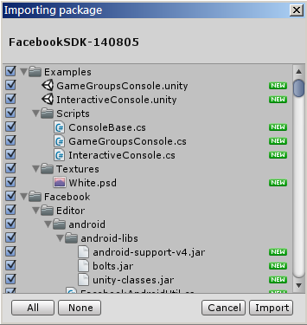

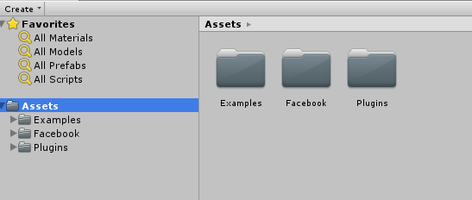

1. Modify source code for iOS

Filename: Assets\Facebook\iOS\FbUnityInterface.mm

Open the FbUnityInterface.mm file

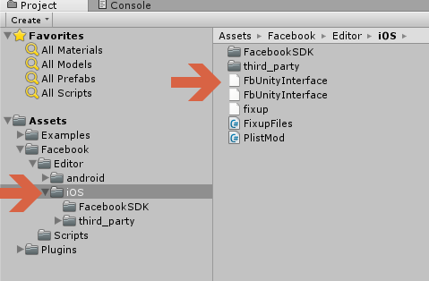

In the -(void)login method

Change the following code

[self.session openWithBehavior:**FBSessionLoginBehaviorWithFallbackToWebView**

to

[self.session openWithBehavior:**FBSessionLoginBehaviorForcingWebView**

This makes Facebook login action always open embedded WebView Login Dialog in iOS device.

1. Modify source code for Android

Filename: Assets\Plugins\Android\facebook\src\com\facebook\unity\FBLogin.java

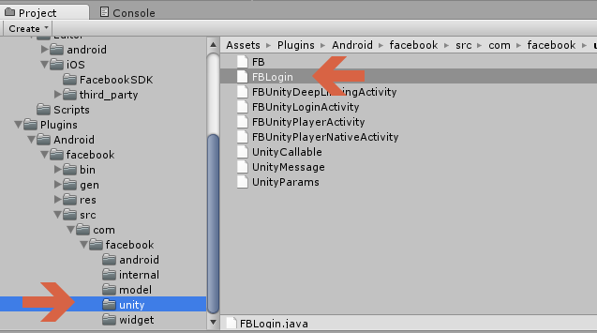

In the sessionOpenRequest method, add two lines of codes

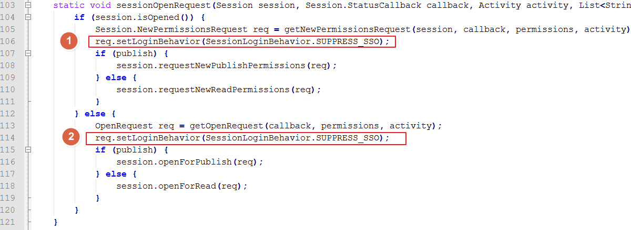

After completing the modification, it is necessary to make the entire java source code listed below to classes.jar. In this case, we make a copy the code and use Eclipse to compile it to classes.jar.

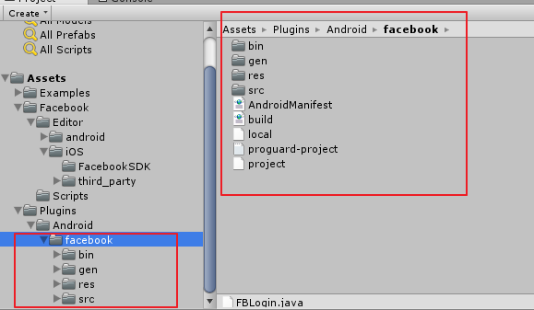

Something needs to be done manually in Eclipse

(1)Change the project name to classes (which will make the output JAR to the filename of classes.jar)

(2)In the project, add a libs folder, and copy android-support-v4.jar, bolts.jar, unity-classes.jar to the libs folder; those three jar files can be found in the Assets\Facebook\Editor\android\android-libs folder

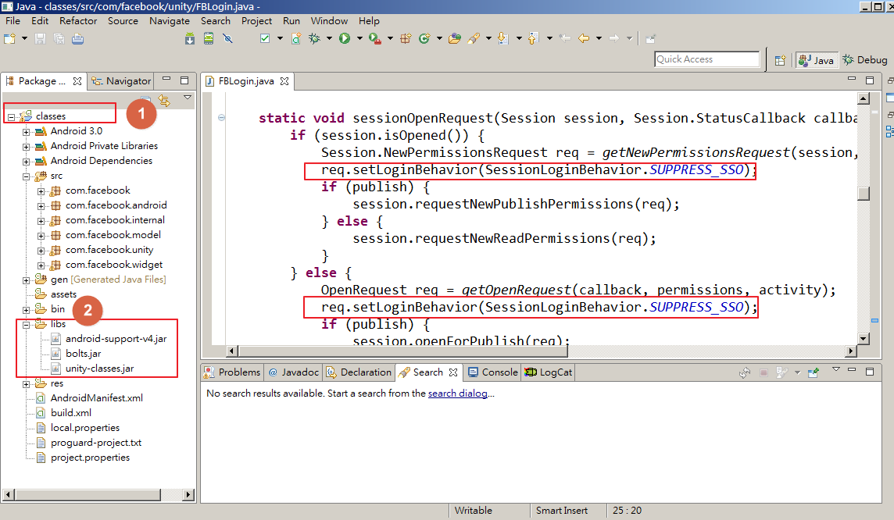

Then, clean the project, build the project, and the output classes.jar file will be found in the \bin folder

Copy the classes.jar to Assets\Plugins\Android\facebook\bin and replace the original one in the Unity project

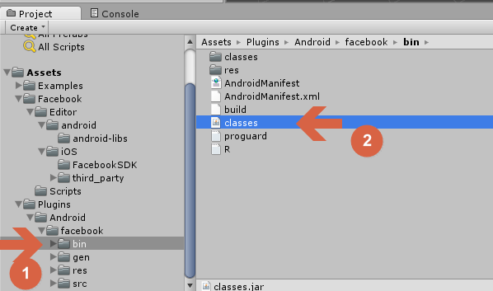

This makes Facebook login action always open embedded WebView Login Dialog in Android device.